Week 7

React-HOL

Features of ES6 (ECMAScript 2015)
- let and const for block-scoped variables
- Arrow functions () => {}
- Template literals: `Hello ${name}`
- Default parameters in functions
- Destructuring: {a, b} = obj
- Rest ...args and spread ...arr operators
- Classes and class inheritance
- Promises for async operations
- Modules (import/export)
- Map, Set, WeakMap, WeakSet collections

JavaScript let
- Declares block-scoped variables (only accessible within {} block).
- Can be updated but not re-declared in the same scope. let x = 10; x = 20; // let x = 30; // Error (in same block)

Difference Between var and let
Feature | var let
Scope | Function-scoped Block-scoped ({})
Redeclaration | Allowed Not allowed in same block
Hoisting | Hoisted (undefined) Hoisted but not initialized
Temporal Dead Zone No Yes, until declared

JavaScript const
- Declares a block-scoped constant variable.
- Value can’t be reassigned.
- Objects and arrays can be mutated, but not reassigned.
const x = 5; x = 10; // Error

const arr = [1,2]; arr.push(3); // allowed

ES6 Class Fundamentals
- Clean syntax to create objects and define methods.
- Uses constructor() method to initialize.
class Person { constructor(name) { this.name = name;
}

greet() { console.log(`Hello, ${this.name}`);
} }

ES6 Class Inheritance
• Use extends to inherit from another class. • Use super() to call the parent constructor.
class Student extends Person { constructor(name, grade) { super(name); // Call parent constructor this.grade = grade;
}
}

Arrow Functions
- Shorter function syntax: const add = (a, b) => a + b
- Don’t bind their own this (lexical this)
- No arguments object or new usage.
const greet = name => `Hello, ${name}`;
set() and map()
- Set: Collection of unique values.
let s = new Set([1, 2, 2, 3]); // {1, 2, 3}
- Map: Collection of key-value pairs (keys can be any type).
let m = new Map();
m.set('name', 'Alice');
m.get('name'); // Alice Code:--

ListofPlayers.js:-
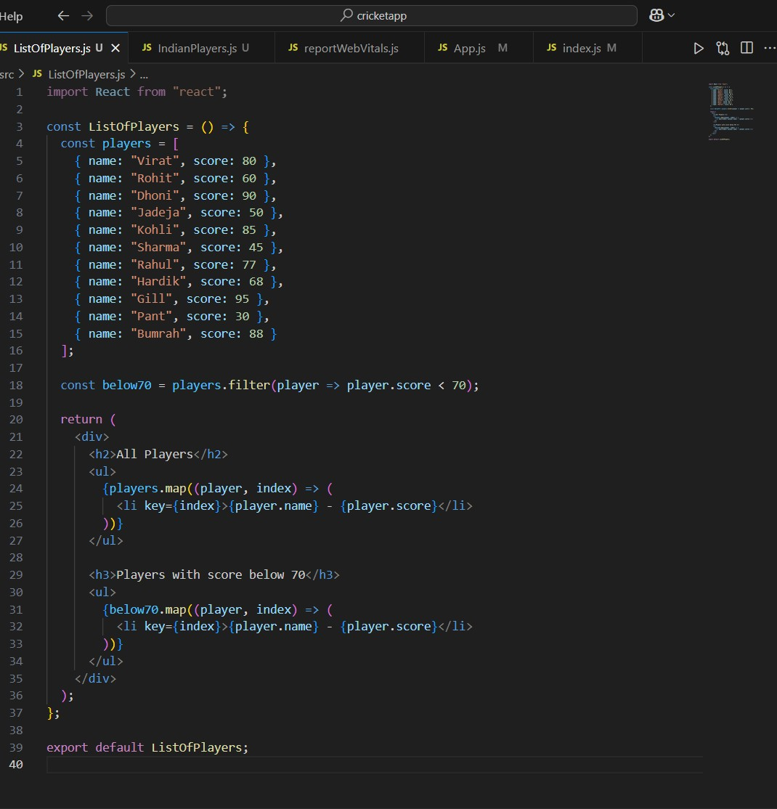

IndianPlayers.js:-
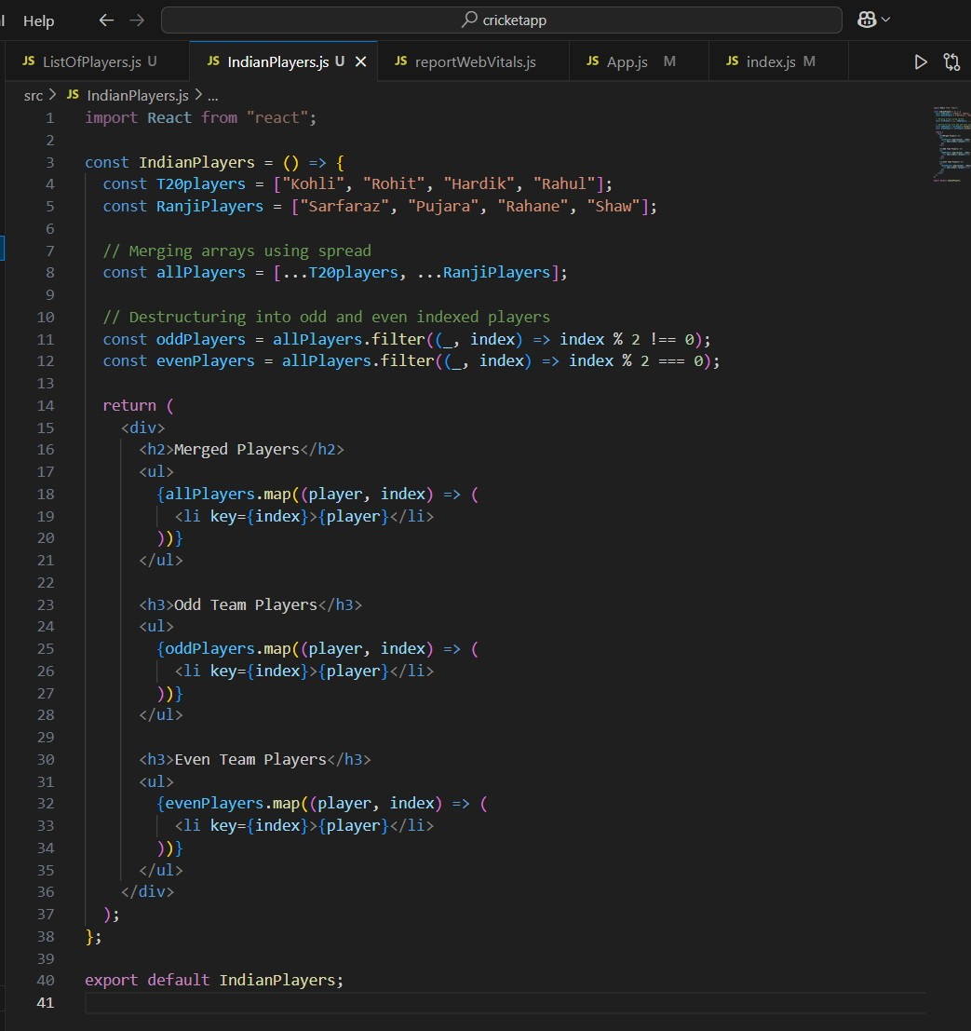

App.js :-
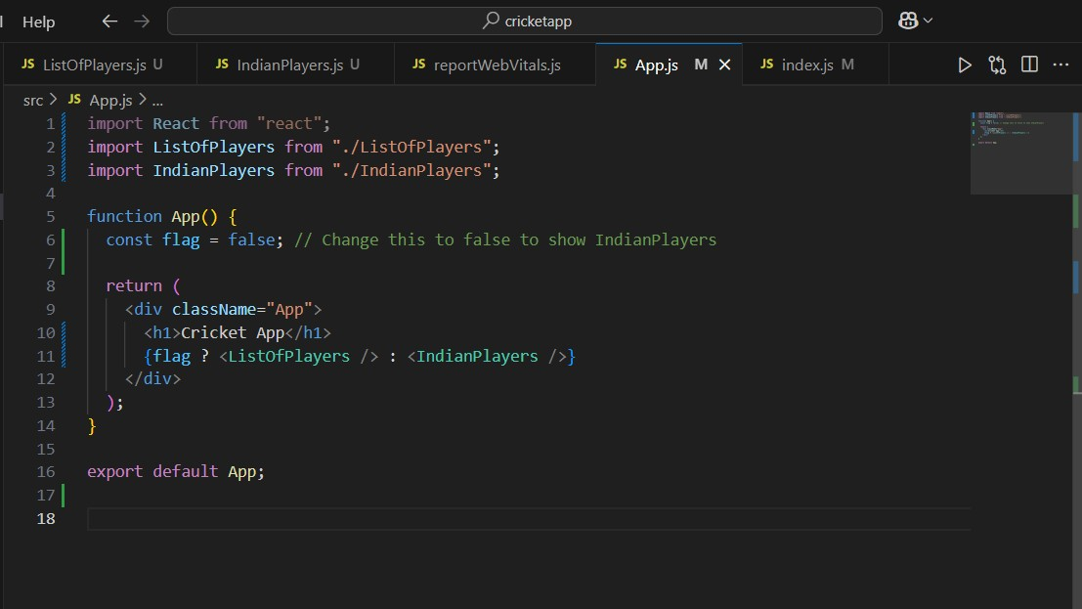

Index.js
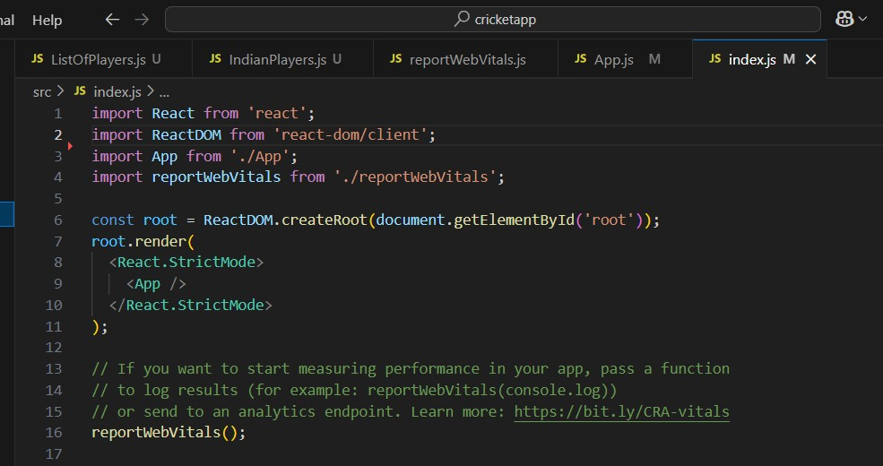

Localhost:3000 :- flag=true
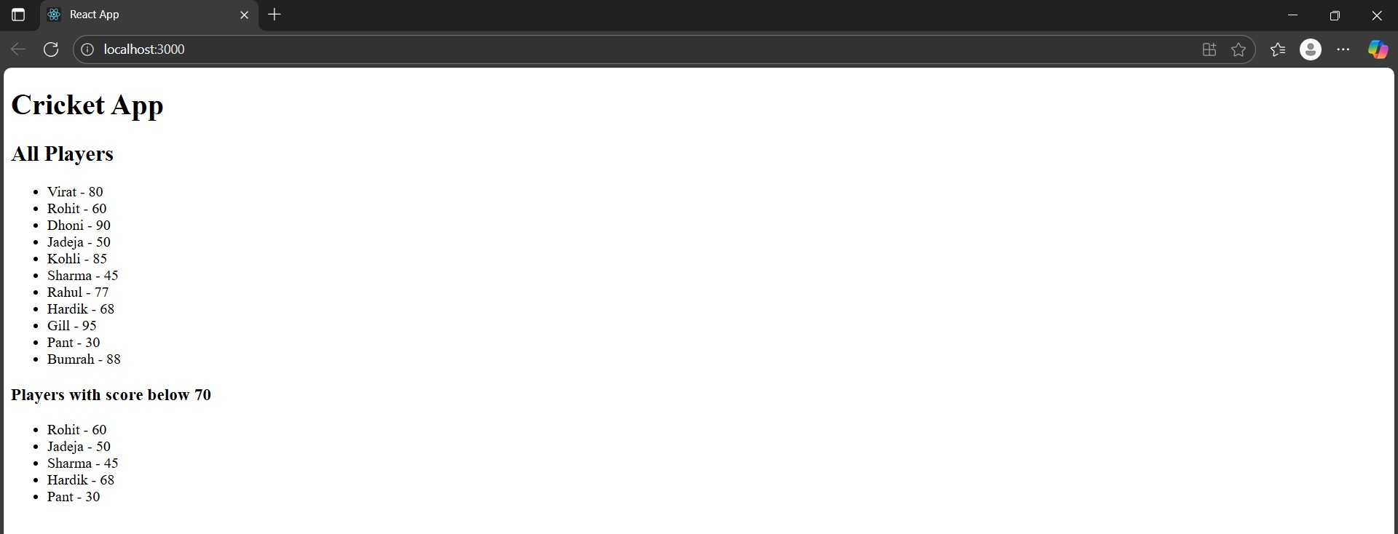

Localhost:3000 :- flag=false
